Attymon NS
School Calendar 2021/2022
July |  |  |  |  |  |  |  | August |  |  |  |  |  |  |  | September
S | M | T | W | T | F | S |  | S | M | T | W | T | F | S |  | S | M | T | W | T | F | S
 |  |  |  | 1 | 2 | 3 |  | 1 | 2 | 3 | 4 | 5 | 6 | 7 |  |  |  |  | 1 | 2 | 3 | 4
4 | 5 | 6 | 7 | 8 | 9 | 10 |  | 8 | 9 | 10 | 11 | 12 | 13 | 14 |  | 5 | 6 | 7 | 8 | 9 | 10 | 11
11 | 12 | 13 | 14 | 15 | 16 | 17 |  | 15 | 16 | 17 | 18 | 19 | 20 | 21 |  | 12 | 13 | 14 | 15 | 16 | 17 | 18
18 | 19 | 20 | 21 | 22 | 23 | 24 |  | 22 | 23 | 24 | 25 | 26 | 27 | 28 |  | 19 | 20 | 21 | 22 | 23 | 24 | 25
25 | 26 | 27 | 28 | 29 | 30 | 31 |  | 29 | 30 | 31 |  |  |  |  |  | 26 | 27 | 28 | 29 | 30
October |  |  |  |  |  |  |  | November |  |  |  |  |  |  |  | December
S | M | T | W | T | F | S |  | S | M | T | W | T | F | S |  | S | M | T | W | T | F | S
 |  |  |  |  | 1 | 2 |  |  | 1 | 2 | 3 | 4 | 5 | 6 |  |  |  |  | 1 | 2 | 3 | 4
3 | 4 | 5 | 6 | 7 | 8 | 9 |  | 7 | 8 | 9 | 10 | 11 | 12 | 13 |  | 5 | 6 | 7 | 8 | 9 | 10 | 11
10 | 11 | 12 | 13 | 14 | 15 | 16 |  | 14 | 15 | 16 | 17 | 18 | 19 | 20 |  | 12 | 13 | 14 | 15 | 16 | 17 | 18
17 | 18 | 19 | 20 | 21 | 22 | 23 |  | 21 | 22 | 23 | 24 | 25 | 26 | 27 |  | 19 | 20 | 21 | 22 | 23 | 24 | 25
24 | 25 | 26 | 27 | 28 | 29 | 30 |  | 28 | 29 | 30 |  |  |  |  |  | 26 | 27 | 28 | 29 | 30 | 31
31
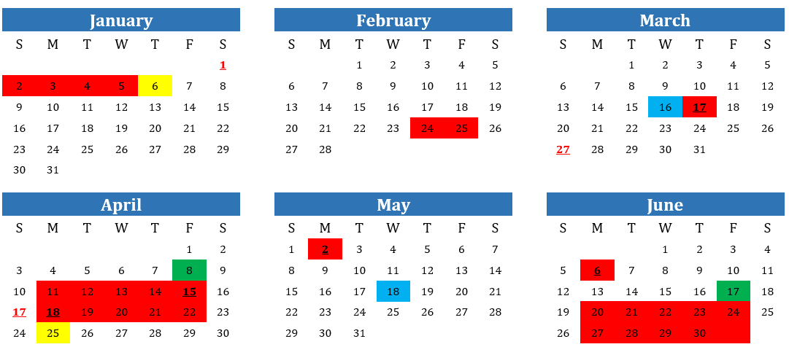
* Some dates may be subject to change
Return to school
School Closed
Staff Meetings (Children go home at 12.30pm)
Parent Teacher Meetings (Children go home at 2.45pm)
Half Days (School Closing at 12.30pm)

